**Android Custom ListView with CheckBox**

Posted by [R.K.Kanojia (Android App Developer)](http://www.androidinterview.com/author/rkkanojia7/)

Android Custom ListView :

By default, the ListView allows one item to be chosen. To enable multiple items to be chosen, you’ll configure the ListView to display a checkbox next to each item. You can combine many components like TextView , CheckBox, ImageView, ImageButton etc. and can make Listview as you require.

You have already learned how to use Simple ListView in old post “[Displaying a List of Items Using the ListView in Android](http://www.androidinterview.com/android-simple-listiview-example/)“. This Example shows you how to add Checkbox in a ListView. We will develop custom array adapter to populate our android Listview with Checkbox.

[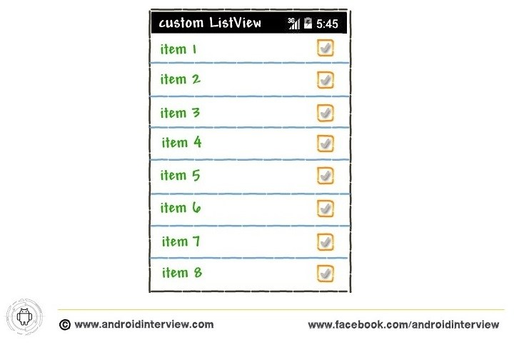](http://i1.wp.com/www.androidinterview.com/wp-content/uploads/2014/08/Custom-listview-checkbox-0.jpg)

*Note : This example (Project) is developed in Eclipse Version Kepler,tested on Android 4.4.2 (KitKat Version) and SDK build-tools 22.6.3*

Solution Stuff :

To configure the ListView, you initially need to get a reference to the ListView. If your activity is extending the ListActivity base class, you’ll use the getListView() method to return an instance of the ListView in your activity. Once you get an instance of the ListView, you’ll call the setChoiceMode() method to set the display mode of the ListView:

Java



|  |  |
| --- | --- |
| 1  2  3  4  5  6 | // -- Display mode of the ListView    ListView listview= getListView();  // listview.setChoiceMode(listview.CHOICE_MODE_NONE);  // listview.setChoiceMode(listview.CHOICE_MODE_SINGLE);  listview.setChoiceMode(listview.CHOICE_MODE_MULTIPLE); |

The ListView.CHOICE_MODE_MULTIPLE constant displays a checkbox next to each item within the ListView. as the user selects each item, the onListItemClick() method is called.

**See figure Multiple choice in listview :**

[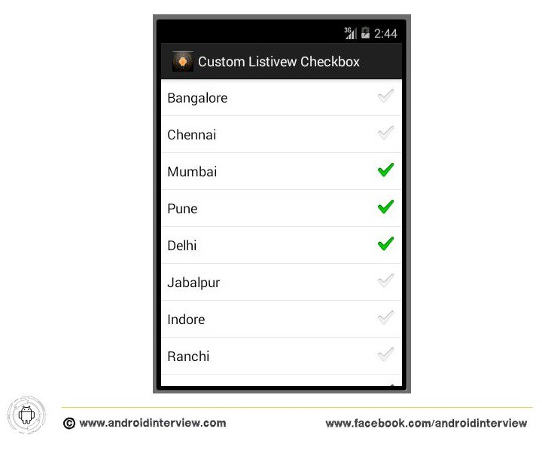](http://i2.wp.com/www.androidinterview.com/wp-content/uploads/2014/08/Custom-listview-checkbox-m.jpg)To determine whether an item within the ListView is checked or unchecked, you’ll use the second argument of the onListItemClick() method:

Java



|  |  |
| --- | --- |
| 1  2  3  4  5 | public void onListItemClick(ListView parent, View v,int position,long id){  CheckedTextView item = (CheckedTextView) v;  Toast.makeText(this, city[position] + " checked : " +  item.isChecked(), Toast.LENGTH_SHORT).show();  } |

The second argument returns the view of the item that was chosen in the ListView. in this case, it returns a CheckedTextView object. using this object, you’ll check whether it’s been checked or not using its isChecked() method.  
Another nice feature of the ListView is its support for text filtering. If your device has a hardware keyboard, typing in the names of the {items|the things} in your ListView can automatically cause the ListView to display only those items that match the text you enter. To enable filtering on the ListView, call the setTextFilterEnabled() method:

Java



|  |  |
| --- | --- |
| 1  2  3  4  5 | //-- text filtering  listview.setTextFilterEnabled(true);    setListAdapter(new ArrayAdapter<String>(this,  android.R.layout.simple_list_item_checked,city)); |

Figure shows what the ListView will look like when you type the characters “ **B** ”.

[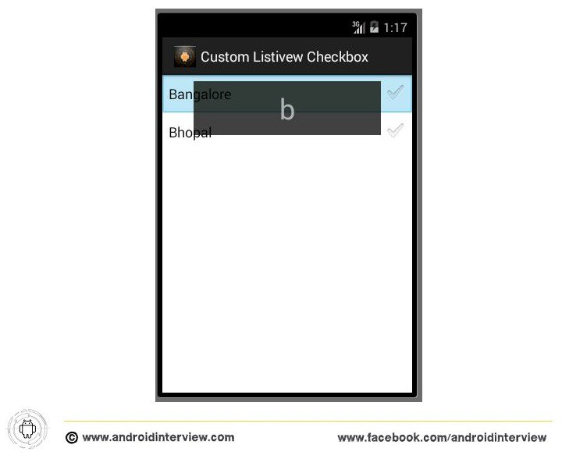](http://i1.wp.com/www.androidinterview.com/wp-content/uploads/2014/08/Custom-listview-checkbox2.jpg)

**Complete Code :**

1. Open “**res/layout/activity_main.xml**” file and put this xml code it into file:

*File : res/layout/activity_main.xml*

XHTML



|  |  |
| --- | --- |
| 1  2  3  4  5  6  7  8  9  10  11  12  13  14  15 | <RelativeLayout xmlns:android="http://schemas.android.com/apk/res/android"      xmlns:tools="http://schemas.android.com/tools"      android:layout_width="match_parent"      android:layout_height="match_parent"      tools:context="${packageName}.${activityClass}" >        <ListView          android:id="@+id/android:list"          android:layout_width="match_parent"          android:layout_height="wrap_content"          android:layout_alignParentLeft="true"          android:layout_alignParentTop="true" >      </ListView>    </RelativeLayout> |

2. Open “**MainAcitvity.class**” file and add following JAVA code.

*File : src/package-name/MainActivity.java*

Java



|  |  |
| --- | --- |
| 1  2  3  4  5  6  7  8  9  10  11  12  13  14  15  16  17  18  19  20  21  22  23  24  25  26  27  28  29  30  31  32  33  34  35  36  37  38  39  40  41  42  43  44  45  46  47  48  49  50  51  52  53  54  55 | package androidinterview.com.customlistivewcheckbox;    import android.app.Activity;  import android.app.ListActivity;  import android.os.Bundle;  import android.view.Menu;  import android.view.MenuItem;  import android.view.View;  import android.widget.ArrayAdapter;  import android.widget.CheckedTextView;  import android.widget.ListView;  import android.widget.Toast;    public class MainActivity extends ListActivity {    String[] city= {  "Bangalore",  "Chennai",  "Mumbai",  "Pune",  "Delhi",  "Jabalpur",  "Indore",  "Ranchi",  "Hyderabad",  "Ahmedabad",  "Kolkata",  "Bhopal"  };    *@Override*  protected void onCreate(Bundle savedInstanceState) {  super.onCreate(savedInstanceState);  setContentView(R.layout.activity_main);    // -- Display mode of the ListView    ListView listview= getListView();  // listview.setChoiceMode(listview.CHOICE_MODE_NONE);  // listview.setChoiceMode(listview.CHOICE_MODE_SINGLE);  listview.setChoiceMode(listview.CHOICE_MODE_MULTIPLE);    //-- text filtering  listview.setTextFilterEnabled(true);    setListAdapter(new ArrayAdapter<String>(this,  android.R.layout.simple_list_item_checked,city));  }    public void onListItemClick(ListView parent, View v,int position,long id){  CheckedTextView item = (CheckedTextView) v;  Toast.makeText(this, city[position] + " checked : " +  item.isChecked(), Toast.LENGTH_SHORT).show();  }  } |

**Output of  Custom Android ListView with CheckBok Android emulator :**

[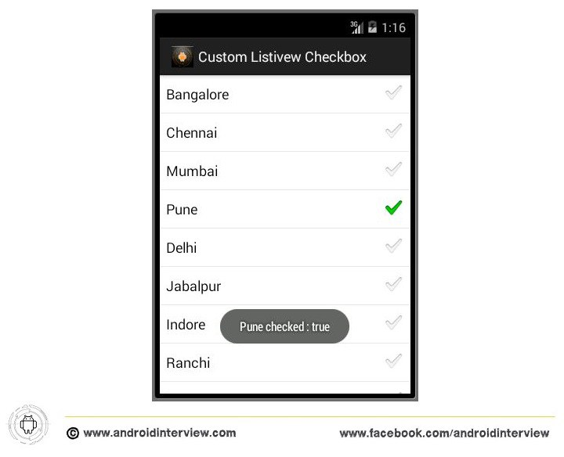](http://i1.wp.com/www.androidinterview.com/wp-content/uploads/2014/08/Custom-listview-checkbox1.jpg)

Download Android Custom ListView with CheckBox example Source code :

|  |
| --- |
| Icon  **Android Custom ListView CheckBox Source code**3.95 MB  [**Android Custom ListView with CheckBox example Download**](http://www.androidinterview.com/android-custom-listview-with-checkbox-example/) |